# CS 255 System Design Document Template

## UML Diagrams

### UML Use Case Diagram

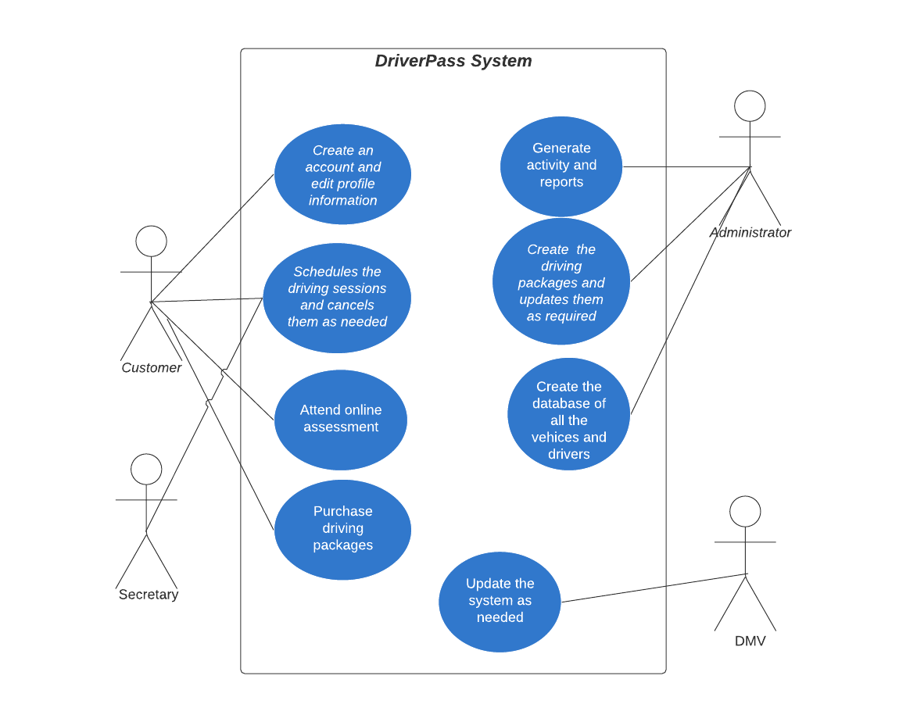

### UML Activity Diagrams

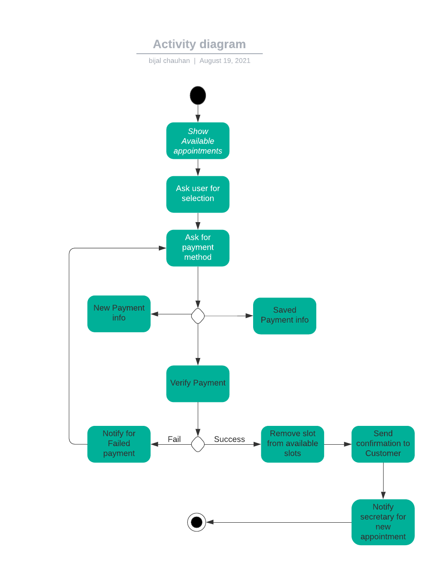

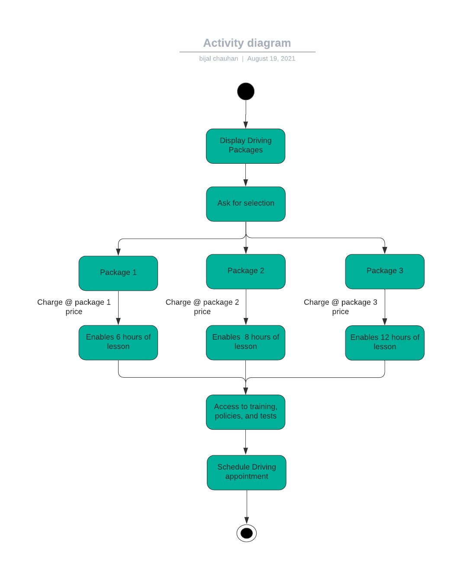

### UML Sequence Diagram

### 

### UML Class Diagram

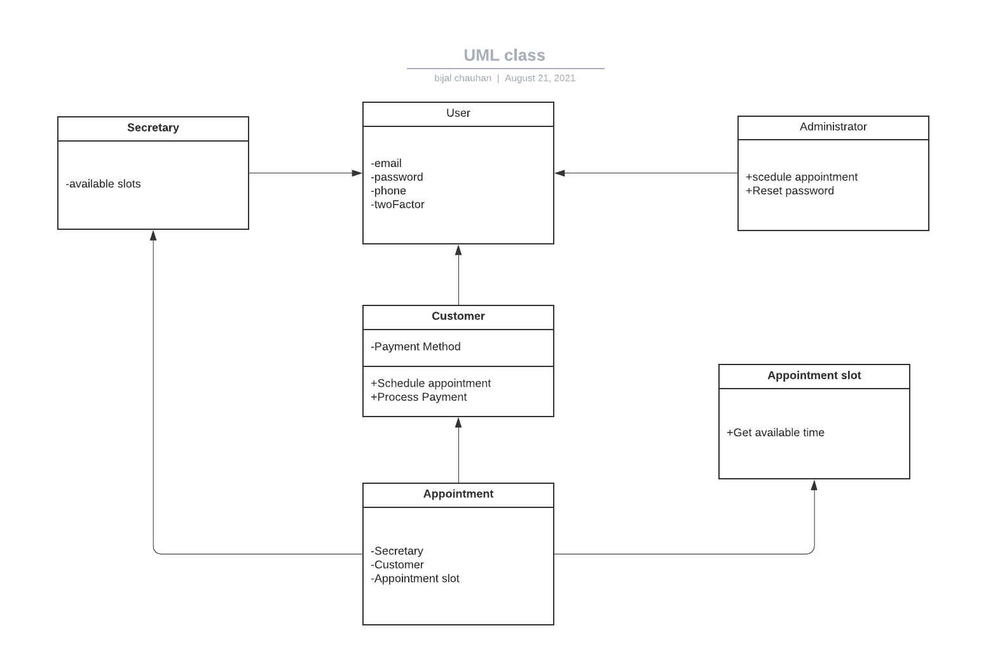

## Technical Requirements

Some of the technical requirements for the system would be as follows:

* A device where one can access to the browser.
* A good internet connection will be required.
* Good service to process the payment online.